ALFIDO TECH INTERNSHIP

TASK 1 – CONTAINERIZATION USING DOCKER

SUBMITTED BY:

Name: Paipalle Thejasree
Candidate ID: BS/REG/119711
Company Name: Alfido Tech
Domain: DevOps Intern
Duration: 2 months

CONTENTS:

1. Objective
2. Technologies Used
3. Project Description
4. Project Structure
5. Files Description
6. Commands Used
7. Execution Process
8. Output Screenshots
9. Learning Outcomes
10. Conclusion
11. Project Links

OBJECTIVE:

The objective of this task is to learn containerization using Docker by creating and deploying a Flask web application inside a Docker container.

TECHNOLOGIES USED:

• Python
• Flask
• Docker
• Docker Compose
• VS Code
• GitHub

PROJECT DESCRIPTION:

A simple Flask web application was created and containerized using Docker. Docker Compose was used to run the containerized application successfully on localhost:5000.

PROJECT STRUCTURE:

ALFIDO INTERNSHIP/
│
├── TASK1-Containerization/
│ ├── app.py
│ ├── requirements.txt
│ ├── Dockerfile
│ ├── docker-compose.yml
│ ├── screenshots/
│ └── README.md
│
└── README.md

FILES DESCRIPTION:

app.py
Contains the Flask web application.

requirements.txt
Contains Python dependencies.

Dockerfile
Contains Docker build instructions.

docker-compose.yml
Defines services and container configuration.

README.md
Contains project documentation.

screenshots
Contains output screenshots.

COMMANDS USED:

docker-compose up --build
Builds and starts the Docker container.

docker ps
Displays running containers.

git init
Initializes Git repository.

git add .
Adds files to staging area.

git commit -m "Task1 completed"
Commits project files.

git push origin main
Pushes project to GitHub.

EXECUTION PROCESS:

1. Installed Python and VS Code.
2. Installed Docker Desktop.
3. Configured WSL for Docker.
4. Created Flask application using Python.
5. Added dependencies in requirements.txt.
6. Created Dockerfile for containerization.
7. Created docker-compose.yml file.
8. Built Docker image using Docker Compose.
9. Ran the container successfully.
10. Verified output in browser using localhost:5000.
11. Uploaded project to GitHub repository.

OUTPUT SCREENSHOTS:

- DOCKER DESKTOP RUNNING:
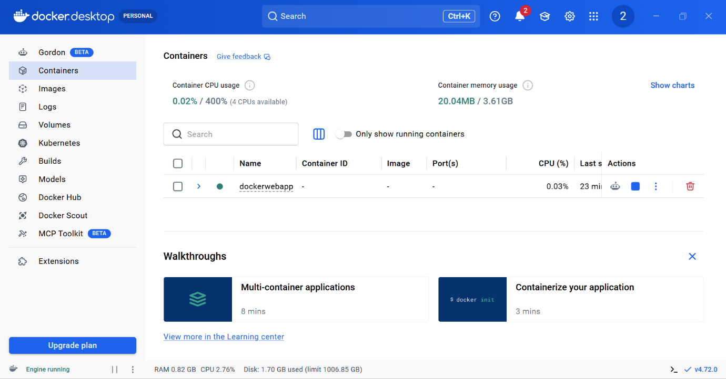

- TERMINAL RUNNING CONTAINER:
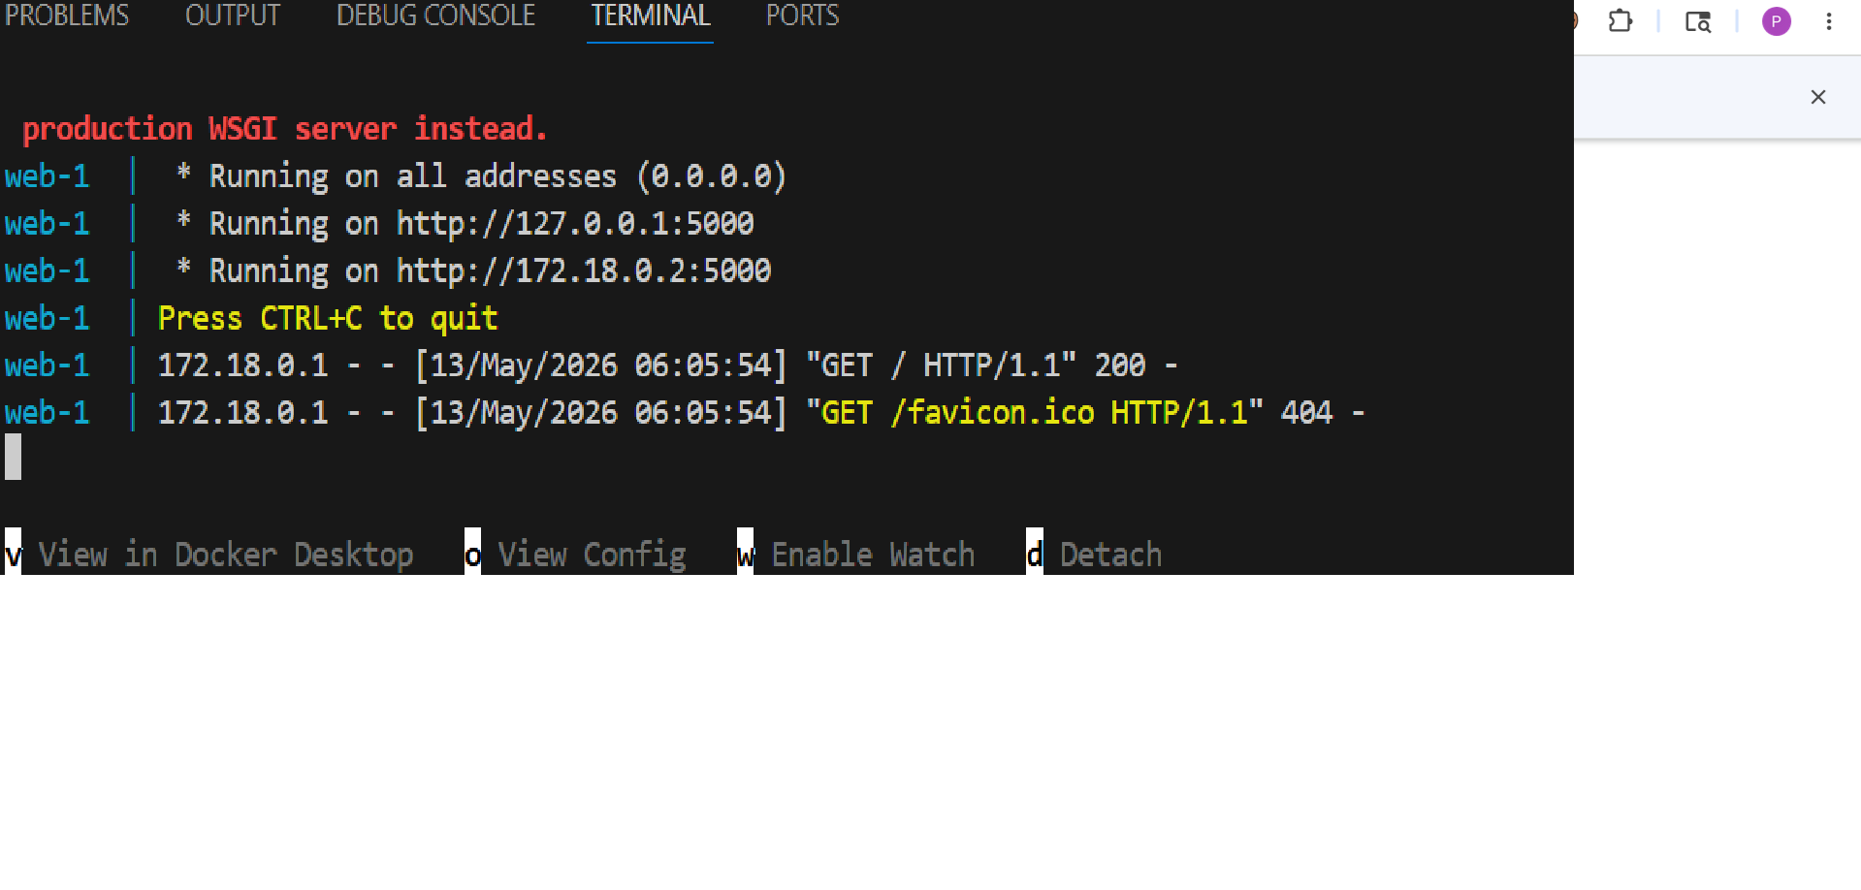

- LOCALHOST OUTPUT IN BROWSER:
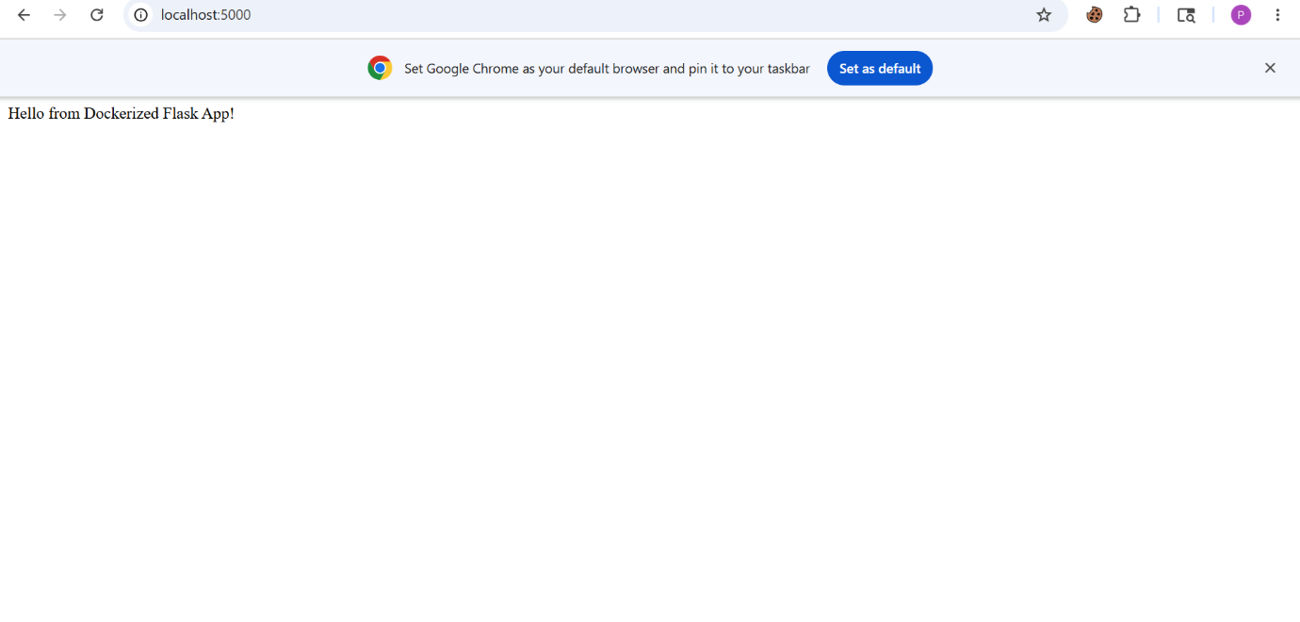
- VS CODE PROJECT STRUCTURE:
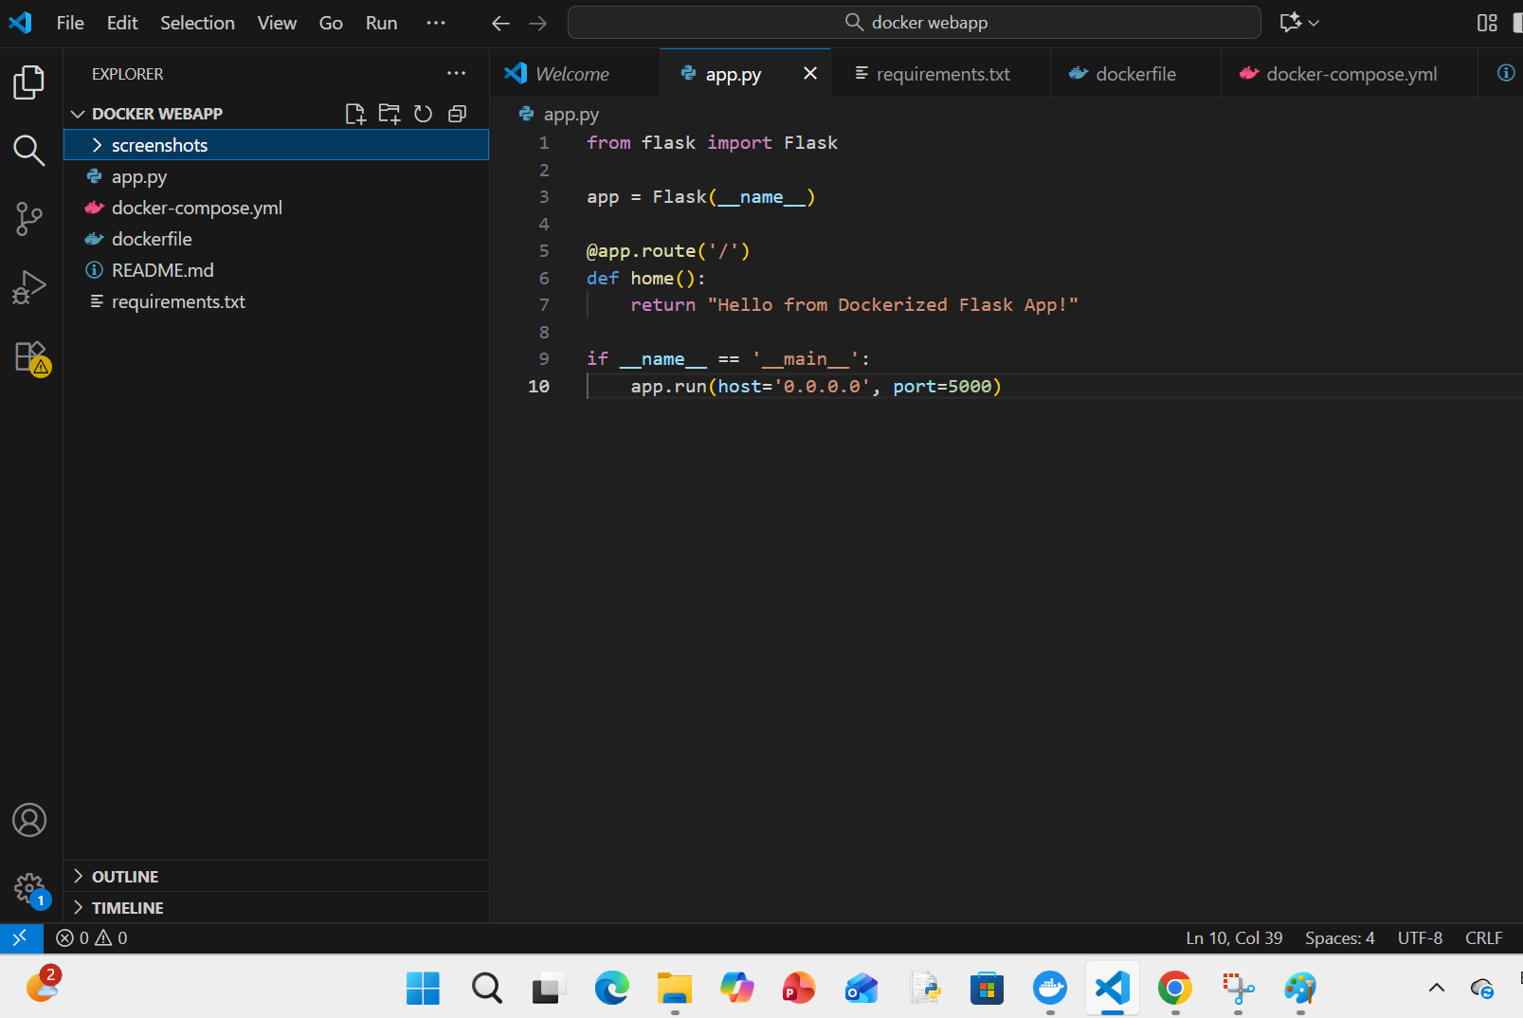
- GitHub repository screenshot:
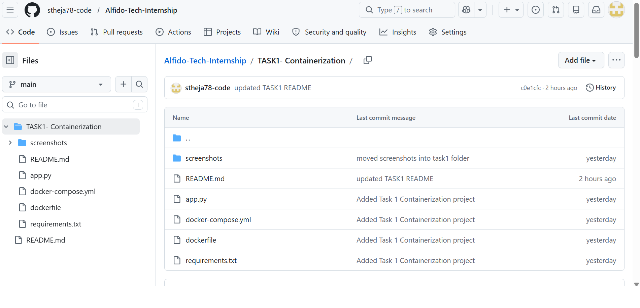

LEARNING OUTCOMES:

• Learned basics of Docker.
• Understood containerization concepts.
• Learned Docker Compose usage.
• Learned Flask application deployment.
• Learned GitHub project management.

CONCLUSION:

Successfully completed Task 1 by containerizing a Flask web application using Docker and Docker Compose. The application was executed successfully and uploaded to GitHub with proper documentation.

PROJECT LINKS:

GitHub repository:

https://github.com/stheja78-code/Alfido-Tech-Internship

LinkedIn Profile:

https://www.linkedin.com/in/paipalle-thejasree

